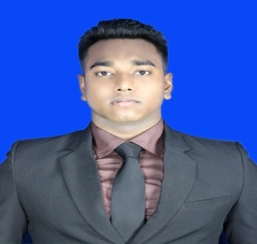**PERSONAL DETAILS**

Name : Md. Anwar Hossain

Father’s Name : Md. Abjal Molla

Mother’s Name : Saleha Begum

Date of Birth : 01-03-1996

Sex : Male

Marital Status : Single

Religion : Islam

Nationality : Bangladeshi

Height : 5 Feet 7 Inch

Blood Group : AB+Ve

Current Address : Palli Bidyut, Ashulia, Savar, Dhaka.

Permanent Address: Faridpur, Dhaka, Bangladesh.

Email Address: anwarhossain7736@gmail.com

ContactNo.: +8801795-700838

**Academic Qualifications:**

|  |  |  |  |  |  |
| --- | --- | --- | --- | --- | --- |
| **Course** | **Institution** | **Department** | **Passing Year** | **Board** | **CGPA** |
| Diploma-In-Engineering | Faridpur Polytechnic Institute | Computer | 2016 | BTEB | 3.29 |
| S.S.C | Talma Nazimuddin High School | Science | 2012 | DHAKA | 4.50 |

**Working Experiences:**

|  |  |  |  |  |
| --- | --- | --- | --- | --- |
| **Sl.** | **Company** | **Department** | **Designation** | **Duration** |
| 01 | ACI Consumer Brands | Sales Development (Automation) | Computer Operator | 1 Year (Running) |

**Personal Attributes:**

Persistent and hard worker.

Ability to work under pressure.

Rapid learner and Self-motivated.

Strong analytical ability.

**Technical Skills:**

**Web Design:**

HTML, CSS.

**Graphics Design:**

Adobe Photoshop, Adobe Illustrator.

**Windows Operating System:**

Windows 7, Windows 8.1, Windows 10, XP.

**Microsoft Office:**

Microsoft Office Word, Microsoft Office Excel, Microsoft Office Access, Microsoft Office PowerPoint.

**Typing Skills:**

Bangla-30 wpm & English-40 wpm.

**Networking:**

IP Addressing, Cable Connection, Router Configuration & Basic Networking.

**My Hobby:**

Exercise, Walking, Travelling, Singing, Internet Browsing.

**Objective:** To be associated with a firm, that provides career development opportunities and to contributes in its progress through my knowledge and skill.

**MD. Anwar Hossain Date...........................**